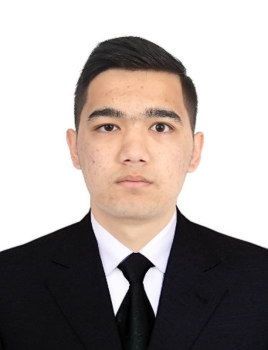

Personal Information

Full name: Abduvohidov Akramjon
Phone: +998901431619
Email: aakromjon3@gmail.com
Location: Tashkent, Olmazor, Ziyo, 4/6, Uzbekistan
Date of Birth: 09.10.2006

Objective

Motivated and responsible university student with international and customer service experience, seeking an opportunity to contribute to company success while developing professional skills.

Education

New Uzbekistan University
Bachelor’s Degree in Chemical and Materials Engineering
2nd Year Student
2024 – present

Work Experience

- Audi, Neckarsulm, Germany
Production Worker
June 2025 – July 2025
- Assisted in production and assembly processes
- Followed workplace safety and quality standards
- Worked effectively as part of a team
- Demonstrated discipline, responsibility, and attention to detail
- Hotel Reception, Tashkent, Uzbekistan
Receptionist
October 2025 – present
- Welcoming and checking in guests
- Handling phone calls and customer inquiries
- Managing reservations and documentation
- Ensuring high-quality customer service and guest satisfaction
Skills
- Customer service and communication
- Teamwork
- Responsibility and reliability
- Fast learner and adaptable
- Computer skills (MS Word, Excel)

Languages
- Uzbek — Native
- Russian — Intermediate
- English — Upper-Intermediate

Hobbies
- Football
- Horse riding
- Table Tenis
- Computer games

